CHAPTER 1
INTRODUCTION

1.1 Introduction
This paper presents the simulation and performance analysis of video communication system along with efficient wireless channels using real time video transmission. Wireless Communication attributes open the technology to a wide variety of applications with its large range and high transmission rate. However, to complement the existing Wireless Communication system with highest transmission rate, the error rate possessed by the same must be as low as possible. Present status of traditional Wireless Communication has been modelled by many researchers. This paper enhances the current status of Wireless Communication system along with modelling of suitable wireless channels i.e. AWGN, Rayleigh, etc. so as to control BER of the system. Further with the variations of different channel parameters for video transmission through Wireless Communication system, the structure compatible to practical scenario can be implemented through this model, using antenna diversity principles along with suitable wireless channels so as to control BER of the system. As a whole the simulation results of this paper will enable the researchers to understand the concept of Wireless Communication system modelling with the finest selection of various types of wireless channels under appropriate circumstances.
When the compressed video bit-stream is transmitted over the error-prone channels such as a packet lossy network, it is possibly corrupted by the channel noise. All information contained in the lost packets will not be available at the decoder and thus the video reconstruction is of a poor quality. Many error resilience techniques such as resynchronization marker insertion and forward error correction (FEC) have been proposed to add side information in the coded bit-stream at the encoder side to make it more resilient to channel errors. H.264/SVC also employs several new error resilience tools to combat the channel errors. However, they still cannot guarantee to compensate the channel errors with good reconstruction quality. To reduce the quality degradations and improve the video quality, error concealment techniques are used at the decoder side as a post-processing module. Channel gain can be improved by adding latest coding techniques at Coder.
1.2 Motivation
With the increasing demand for multimedia services on mobile terminals, and the recent advances in mobile computing, video services are expected to be widely deployed. Over the last couple of years, delivering video services to users over wireless networks has become possible with advances in low bit rate video coding. Videoconferencing has been conjured to be a key mode of communication between people in the future. Multimedia allows people to share media rich information in a format that is comprised of text, audio, still images, and video. Collaborative systems are one another consumer of video conferencing / telephony systems. These systems require interaction among various users by the way of multimedia communication, leading to a better information dispatch. Clearly, with the increase in bandwidth, the world is moving towards high bit rate communication. Video-on-demand applications are also gaining increased popularity. Thus, the world seeks visually enhanced video contingent with all resource limitations.

The advances in low bit-rate video coding technologies have led to the possibility of delivering video services to users through band-limited wireless networks. ITU-T worked on a standard for such applications and developed H.264. H.264 is a compression standard developed to transmit video using the phone network at data rates less than 64kbps. Adoption of the H.264 video compression standard for the wireless video applications seems ideal, since the bit rate criterion is met.

Any path towards a better system has its own set of obstacles that hinder the overall performance. Owing to the applied compression, H.264 is very vulnerable to bit errors and normal video transmission system does not guarantee such a quality. Fading on radio channels causes significant transmission errors. Hence extraneous effort is need to control error in the video streams. This is the true reason for incubation of this thesis work. There are various proposals for error control and ultimately improving video quality. This thesis deals predominantly with Forward Error Correction (FEC) based control.

1.3 Research Objective and Scope
For effective video communications, reduction of raw video data rates is only one of the necessary steps. Another equally important task is handling errors and losses in a communication network. In contrast with data communications, which are not usually subject to strict delay constraints and can therefore be handled using network protocols that use retransmission to ensure error free delivery, real- time video is delay sensitive and cannot easily make use of retransmission. The extensive use of predictive and variable-length coding in video coding renders compressed video especially vulnerable to transmission errors, and successful video communication in the presence of errors requires careful designs of the encoder, decoder and other system layers.

Forward error correction, which is regarded as the proactive mode of error control, is a popular strategy adopted in most system attributing to its low recovery time and latency. In FEC, irrespective of whether the channel has error at that particular instant, error protection is provided. This thesis research work is focused towards enhancing the error resilience of H.264stream by way of FEC coding. The proposed solutions in this thesis can be applied to other error-prone systems too. But, the gravity of the wireless applications deemed it important to be considered as the primary target. Performance evaluation and comparison of the various schemes calls for appropriate performance metrics. In the case of video telephony, quality of the pictures is the main aspect under serious consideration. Quality refers to closeness of the reconstructed video to the original video transmitted. This integrates the factors of frame rate, continuity of motion, chrominance levels and luminance levels. The main objective is to maximize the quality of the received video stream by employing of FEC coding. Different modifications to the original H.264 protocol are considered keeping in mind the reconstructed video quality. Identifying all deterrents is the first step in the project. The anomalous cases, where the conventional forward error correction will not aid the quality, it is also needed to be identified. FEC coding brings in more overhead in the video stream thereby reducing the system throughput.

This situation needs to be remedied by optimizing the required number of the parity bits. There is a high processing lag in performing the error correction operation. This needs to be resolved by determining when exactly the FEC is required. The challenge is to make best use of the overhead bits so as to achieve the highest reconstructed video quality.

1.4 Thesis Outline
The chapters in this thesis are organized as follows.

In Chapter 1, the introduction, motivation of the project, and research objective and scope of the project have been discussed.

In Chapter 2, Literature survey related to the project has been discussed.

In Chapter 3, the required background for understanding the research work is presented. All details on the adopted video compression standard H.264, motion estimation and motion compensation, block matching algorithms have been discussed.
Further it deals with the error control techniques in video communication. Many error control techniques such as layering, forward error correction, and retransmission have been discussed. FEC codes have also been discussed in this chapter which is used for forward error correction in this thesis. The concepts of quality estimation based on reconstructed video and transmission rate control are also discussed in quite some detail. This chapter also deals with the wireless channel characteristics. The matched filter detector is also discussed which is used in this thesis to estimate the received bits at the receiver side.

Chapter 4 deals with the proposed video transmission model, the block diagram, the methodology of the processing of error free video transmission and operation of the compression and channel coding blocks.

Chapter 5 presents the simulation methodology and designing of each block. This chapter gives description about each block which is used to design the simulink model of video transmission system.

Chapter 6 provides the result analysis of the proposed video transmission system. The results generated have tabulated and further analyzed in this section. The discussions are from higher perspective and compare the various schemes, basing peak signal to noise ratio as the quality determinant. This chapter also suggests limitation brought in by each scheme.
Finally, Chapter 7 provides the conclusion of this thesis work. The insights generated from the research work have been highlighted in this section. Momentum for further improvement of video quality has been provided in the form of future work.

CHAPTER 2
LITERATURE SURVEY
Generally, digital compressed video is considerably vulnerable to transmission errors, due to the use of predictive and variable-length (entropy) coding. Even a single bit error can lead to damage of a whole block or set of video blocks. In contrast with simple data communications, which are not subject to strict delay conditions, real-time video transmission is delay sensitive and cannot make use of retransmission in order to ensure error-free delivery of the video data. Therefore, successful video communication in the presence of errors requires careful design of the systems. Many have presented several methods of compression and error resilient video transmission.

Elsevier J. of Visual Communication & Image Representation (Special issue on Emerging H.264/AVC Video Coding Standard), Vol. 17(2), April 2006
Real-time transmission of video data in network environments, such as wireless and Internet, is a challenging task, as it requires high compression efficiency and network friendly design. H.264/AVC is the newest international video coding standard, jointly developed by groups from ISO/IEC and ITU-T, which aims at achieving improved compression performance and a network-friendly video representation for different types of applications, such as conversational, storage, and streaming. In this paper, we discuss various error resiliency schemes employed by H.264/AVC. The related topics such as non normative error concealment and network environment are also described. Some experimental results are discussed to show the performance of error resiliency schemes.

Motion estimation techniques for digital TV: a review and a new contribution The key to high performance in image sequence coding lies in an efficient reduction of the temporal redundancies. For this purpose motion estimation and compensation techniques have been successfully applied. This paper studies motion estimation algorithms in the context of first generation coding techniques commonly used in digital TV. In this framework, estimating the motion in the scene is not an intrinsic goal. Motion estimation should indeed provide good temporal prediction and simultaneously require low overhead information. More specifically the aim is to minimize globally the bandwidth corresponding to both the prediction error information and the motion parameters.

Jain, Jaswant, and Jain, Anil, “Displacement Measurement and Its Application in Interframe Image Coding”, A new technique for estimating interframe displacement of small blocks with minimum mean square error is presented. An efficient algorithm for searching the direction of displacement has been described. The results of applying the technique to two sets of images are presented which show 8-10 dB improvement in interframe variance reduction due to motion compensation. The motion compensation is applied for analysis and design of a hybrid coding scheme and the results show a factor of two gain at low bit rates.

Chen,Lei and Lee, Chung-wei, “Multi-level secure video streaming Over SRTP”, have proposed a set of solutions to four different levels on data selection for encrypting Motion JPEG video frame over SRTP. These solutions are based on our intensive analysis of the JPEG image compression procedure. Author selected the most important data which contains most information of an image for encryption; in consequence provide a set of balances between security and computation for different hardware environments. Extensive experiments are conducted and performance data has been analyzed to evaluate the proposed solutions. These solutions are well suited in different scenarios with various computation power and security requirements.

Chunbo Zhu, Ye-Kui Wang, M.M. Hannuksela, Houqiang Li, “Error Resilient Video Coding Using Redundant Pictures”, has presented several error resilient video coding methods based on redundant pictures. They combined redundant picture coding with reference picture selection and reference picture list reordering to prevent error propagation in motion compensated video coding. A hierarchical redundant picture allocation method is employed to make a tradeoff between error resilience and coding efficiency. For improved end-to-end rate-distortion performance in packet loss environment, three adaptive redundant picture allocation methods are further developed, utilizing characteristics of the input video content. Simulation results show that the adaptive redundant picture coding methods can achieve average luma peak-signal-to-noise improvements up to 3.5 dB compared to the loss-aware rate distortion optimized intra macroblock refresh algorithm implemented in the H.264/AVC Joint Model (JM). The proposed redundant picture coding methods are standard-compliant and do not introduce any additional end-to-end delay, therefore suit for low-delay applications such as video telephony and video conferencing. Due to the good error resilience performance, some of the proposed redundant picture coding methods have been adopted and integrated into the JM.

Marios G. Hadjinicolaou, Kostas E. Psannis and Yutaka Ishibashi “Error Resilient Interactive Video Streaming Over Wireless Networks”, Error resilient (re)-encoding is a key technique that enables robust streaming of stored video content over noisy channels. It is particularly useful when content has been produced independent of the transmission network conditions. In this paper, they have investigated the constraints of supporting normal /interactive multimedia services in wireless clients. In order to overcome these additional resources we proposed the use of multiple differently encoded version of each video sequence. The differently coded video is obtained by encoding frames of the original (uncompressed) sequence as a I-P(I) frames using different GOP pattern for the normal wireless stream. On the other hand, the interactive wireless streams are obtained by encoding every Nth frame of the original (uncompressed)- file as a sequence of I-P(Marionette)-frames. This allows for support of fully interactive operations at variable speedups. All versions of the original sequence are stored in the system’s server. The server responds to an interactive request by switching from the currently transmitted version to another version. By proper encoding versions of the original video sequence, video streaming services can be supported with considerably reduced additional delay and minimum jitter which implies acceptable visual quality at the wireless client –end. Moreover full interactive wireless video streams can be supported with considerably reduced additional storage, network bandwidth and decoder complexity respectively.

CHAPTER 3
BACKGROUND
This chapter discusses some of the important concepts that needed reading and that are also applied in this thesis work. As much detail is provided it will be required to understand the core of the research. Importance is given to the basics of H.264 video compression and the various error control techniques. The theory behind some of the optimization is explained in this section.

3.1 Motion-Compensated Hybrid Coding

General Principles
Most state-of-the-art low bit-rate video codecs are motion-compensated hybrid codec’s, as illustrated in Figure 3.1. Two basic modes of operation can be selected, depending on the position of the switch. These two modes allow the video signal in the current frame to be encoded either directly (INTRA coding), or with reference to previously encoded and reconstructed frames (INTER coding). The INTER mode combines differential pulse code modulation (DPCM) along an estimated motion trajectory with intraframe encoding of the residual prediction error. Motion compensated prediction is carried out by estimating the motion between successive frames, shifting the contents of a previously encoded, reconstructed frame accordingly, and transmitting the motion vector in addition to the prediction error residual as side information. The residual prediction error is usually small and requires fewer bits than directly encoding the original video signal. In all current compression standards, the discrete cosine transform (DCT) is employed for this purpose with a block size of 8x 8 pixels. The transform coefficients are quantized and typically encoded as a series of zero-runs and quantizer levels. Transform coefficients and motion vectors are entropy coded along with other side information resulting in variable-length code words, which are multiplexed to the video bit stream. For most of a video signal, the INTER mode is the preferred mode because of its superior coding efficiency. However, some changes in successive frames, for example, due to uncovered background, new objects appearing in the scene, or after a scene cut, cannot be predicted well, and subtracting the prediction might lead to a prediction error that requires more bits than the original video signal. Therefore, the second basic encoding mode besides INTER coding is the INTRA mode, in which no reference to previous frames is made and the picture is directly intraframe coded. Again, a variety of schemes can be used, but typically a blockwise 8x8 DCT coder is employed.
Figure 3.1: (a) Motion compensated encoder (b) Decoder.

3.2 The H.264 Coding Standard
H.264 was designed for very low bit rate coding applications.H.264 is based on H.261 but it is significantly optimized for coding at low bit rates. H.264 is the video compression standard for low bit rate communications. It prescribes procedures to derive a 64 Kbps video stream from the raw motion samples (like QCIF). A hybrid of inter-picture prediction to utilize temporal redundancy and transform coding of the remaining signal to reduce spatial redundancy is adopted. Most of these procedures are found in MPEG encoding too. Both fixed length and variable length coding is used for the symbols to be transmitted.

The general principles discussed above are the basis for all video compression standards in use today, in particular the ISO standards MPEG-1, MPEG-2 , and MPEG- 4, and the ITU-T Recommendations H.261, H.262 (identical with MPEG-2), and H.264 . We will use H.264 as an example throughout this paper. H.264 is the video compression standard for low bit rate communications. The picture resolution is often quarter common intermediate format (QCIF, 176x144 pixels), which is the most common input format at such low bit rates. At QCIF resolution, each picture is divided into 11x9 macro blocks (MB’s), which comprise 16x16 luminance samples, and two corresponding 8x8 blocks of chrominance samples.

The luminance component of each MB is further subdivided into four 8x8 blocks, such that 8x8 DCT’s can be applied to each block. Each MB is encoded either in INTRA or INTER mode. Motion compensation is carried out with half-pixel accuracy with one motion vector sent for each MB.

The encoding process is divided into the following steps: motion estimation, prediction calculation, DCT type estimation, subtraction of prediction from picture, DCT calculation, DCT coefficients quantization and generation of VLC data, picture interpolation, inverse DCT coefficients quantization and finally IDCT calculation and addition of predicted image. Due to the use of the motion compensated temporal interpolation technique, three different types of encoded images are produced, by using the following three different coding modes: Intra mode: images encoded individually without using temporal prediction (without reference no any other picture); Predicted mode (P-pictures): inter frame coded pictures using unidirectional MC prediction; Bi-directional mode: which generates inter frame coded pictures using bi-directional motion compensated prediction. B-frames may be encoded using either forward prediction where reference is made to an image in the past, backward prediction where reference is made to a future image, and finally to an image in the past and one in the future.

Figure 3.2: (a) Forward prediction.

Figure 3.2: (b) Backward Prediction.

The I picture frame at the beginning of a GOP serves as a basic entry point to facilitate random seek or channel switching and also provides coding robustness to transmission error, but it is coded with only moderate compression to reduce the spatial redundancies. P picture frames are coded more efficiently using motion compensated prediction from a past I or P picture frame and generally used as a reference for further prediction. B picture frames provide the highest degree of compression, but require both past and future reference pictures for motion compensation. It should be mentioned that B pictures are never used as references for prediction. The structure of the GOP needs to be specified. This specification indicates the number of frames in a GOP, the number of P frames in a GOP, the number of B frames in a GOP, and the interleaving of the I, P, and B frames in the GOP. The GOP structure is specified using two integer parameters, N and M. N specifies the number of frames in the GOP. M specifies the length of the substructure in the GOP (i.e., after each I frame or P frame, there are M–1 consecutive B frames before the next I or P frame). N must be an integer multiple of M. The default GOP pattern is IBBPBBPBB (i.e., N =9, M = 3). To maximize coding efficiency, both the motion compensation information and the transformed prediction error are represented using variable length (Huffman) codes (VLC).

The figure 3.3 below depicts the syntax of H.264 frame. In H.264 only I and P pictures are considered and not there are no B pictures. These predictive-coded frames (P frames) are coded in terms of differences of the current image relative to the previous I or P frame. For coding efficiency, each picture is divided into macro blocks, where each macro block consists of four luminance blocks and two spatially aligned colour difference blocks. Each block consists of 8 pixels x 8 lines of luminance or chrominance. One or more macro block rows are combined into a group of blocks (GOB) to enable quick resynchronization after transmission errors. Each picture consists of 9 Group of Blocks (GOB, which in turn contains 11 macro blocks(MB). Each macro block contains 4 luminance components and 2 chrominance components.

Figure 3.3: Simplified syntax diagram for the H.264 video bit stream.

Each frame (also called picture) comprises of 9 Group of Blocks (GOB), which in turn contains 11 Macro blocks(MB). Each macro block contains 4 luminance components and 2 chrominance components.

3.2.1 Intraframe Coding
The spatial redundancy is exploited using the intraframe coding. The word spatial refers to space in a single picture and the goal of spatial compression is to minimize the duplication of data in each picture. Bit rate reduction in spatial compression is achieved by first transforming the video data from the space and time domain into the frequency domain using the discrete cosine transform (DCT) method and then applying quantization and variable length coding techniques to reduce the bit rate. To accomplish data reduction, we must first transform the video data into the frequency domain. This is where DCT (a trigonometrically formula derived from Fourier analysis theory) is used to transform the data in each block of 8x8 pixels into blocks of 8x8 frequency coefficients. In the frequency domain, most of the high energy (and therefore most noticeable) picture elements are represented by low frequencies at the top left corner of the block, and the less important details are revealed as higher frequencies towards the bottom right At this stage we have not yet discarded any bits.

Figure 3.4: Zig-zag scanning.

After DCT encoding, the data is subjected to a quantization process, weighted to reduce data in the high frequency areas, where the eye is less sensitive. We use more bits per pixel to quantize the important low-frequency coefficients and fewer bits per pixel for the high-frequency coefficients.

The DC components are normally quantized at 10 bits, because if we employ coarser quantization of very low frequencies, the blocks themselves can start to become visible in the pictures. We have now achieved the first step in spatial bit rate reduction. To create the compressed video bit stream, the 64 frequency coefficients are scanned in a zig-zag fashion from top left to bottom right and, the high-frequency areas are represented by strings of zeros. Further data reduction can now be achieved by transmitting only the number of zeros instead of the usual values of the coefficients. The last stage in the spatial compression process employs variable length coding (VLC). VLC assigns shorter code words for frequently occurring events and longer code words for less frequent events; it is also reversible.

3.2.2 Interframe Coding
Interframe processing is the key to exploit and reduce the temporal redundancy in digital video compression. Temporal redundancy results from a high degree of correlation between adjacent pictures. B and P pictures are based upon the Interframe coding techniques. The encoding process for P and B pictures is explained as follows. Data representing macro blocks of pixel values for a picture to be encoded are fed to both the substractor and the motion estimator. The motion estimator compares each of these new macro blocks with macro blocks in a previously stored reference picture or pictures. It finds the macro block in the reference picture that most closely matches the new macro block. The motion estimator then calculates a Motion Vector(MV) which represents the horizontal and vertical displacement from the macro block being encoded to the matching macro block-sized area in the reference picture. Note that the motion vectors have 1/2 pixel resolution achieved by linear interpolation between adjacent pixels. The motion estimator also reads this matching macro block (known as a predicted macro block) out of the reference picture memory and sends it to the substractor which subtracts it, on a pixel by pixel basis, from the new macro block entering the encoder. This forms an error prediction or residual signal that represents the difference between the predicted macro block and the actual macro block being encoded. This residual is often very small. The residual is transformed from the spatial domain by a 2 dimensional DCT. (The two dimensional DCT consists of separable vertical and horizontal one-dimensional DCTs.) The DCT coefficients of the residual are then quantized in a process that reduces the number of bits needed to represent each coefficient. Usually many coefficients are effectively quantized to 0.

The quantized DCT coefficients are Huffman run/level coded which further reduces the average number of bits per coefficient. This is combined with motion vector data and other side information (including an indication of I, P or B picture) and sent to the decoder. The following sections describe the problem of Motion Estimation and different proposed algorithms to solve this problem.

3.3 Introduction to Motion Estimation and Compensation
The movement of a macro block from the reference frame to the current frame is determined using a technique known as motion estimation. A search of a macro block in the current frame is conducted over a portion (or all) of the reference frame. The best matching macro block (under certain criteria) is selected, and a motion vector is obtained. A motion vector consists of horizontal and vertical components. This motion vector can be expressed in integer or half-pixel accuracy. Half-pixel accuracy corresponds to bilinear interpolation. A predictive frame is constructed from the motion vectors obtained for all macro blocks in the frame. Macro blocks from the reference frame are replicated at the new locations indicated by the motion vectors. This technique is known as motion compensation. A predictive error frame (PEF) is calculated by taking the difference between the current and predicted frames, and intra frame encoded. Since the energy of the PEF is likely to be low, the amount of bits necessary for its encoding is small. Motion compensation is used both at the encoder and the decoder to produce a motion compensated version of the current frame. This motion compensated frame is reconstructed by using the predicted frame and the PEF.

3.3.1 Block Matching Algorithm
Figure 3.5: Block matching a macro block of side 16 pixels and a search parameter p of size 7 pixels.

The underlying supposition behind motion estimation is that the patterns corresponding to objects and background in a frame of video sequence move within the frame to form corresponding objects on the subsequent frame. The idea behind block matching is to divide the current frame into a matrix of ‘macro blocks’ that are then compared with corresponding block and its adjacent neighbours in the previous frame to create a vector that stipulates the movement of a macro block from one location to another in the previous frame. This movement calculated for all the macro blocks comprising a frame, constitutes the motion estimated in the current frame. The search area for a good macro block match is constrained up to p pixels on all fours sides of the corresponding macro block in previous frame. This ‘p’ is called as the search parameter. Larger motions require a larger p, and the larger the search parameter the more computationally expensive the process of motion estimation becomes. Usually the macro block is taken as a square of side 16 pixels, and the search parameter p is 7 pixels. The idea is represented in Fig 3.5. The matching of one macro block with another is based on the output of a cost function. The macro block that results in the least cost is the one that matches the closest to current block. There are various cost functions, of which the most popular and less computationally expensive is Mean Absolute Difference (MAD) given by equation (3.1). Another cost function is Mean Squared Error (MSE) given by equation (3.2).

$$MAD=\frac{1}{N^{2}}\sum_{i=0}^{N-1}{\sum_{j=0}^{N-1}{\left|C_{ij}-R_{ij}\right|}} (3.1)$$

$$MSE=\frac{1}{N^{2}}\sum_{i=0}^{N-1}{\sum_{j=0}^{N-1}{({C_{ij}-R_{ij})}^{2 } (3.2)}}$$
Where N is the side of the macro bock, $C_{ij}$ and $R_{ij}$ are the pixels being compared in current macro block and reference macro block, respectively.

3.3.2 Exhaustive Search (ES)
Given an image block in the anchor frame Km , the motion estimation problem at hand is to determine a matching block Km in the target frame such that the error between these two blocks is minimized. The displacement vector dm between the spatial positions of these two blocks is the MV of this block. Because the estimated MV for a block affects the prediction error in that block only, one can estimate the MV for each block individually, by minimizing the prediction error accumulated over each block, which is:
$E_{m}\left(d_{m}\right)=\sum_{xϵβ_{m}}{|Ψ_{2}(x+d_{m}-Ψ_{1}(x))}|^{p}$ (3.3)

One way to determine the $d_{m}$ that minimizes this error is by using exhaustive search, and this method is called the exhaustive block-matching algorithm (EBMA). As illustrated in Figure2.6, the EBMA determines the optimal dm for a given block Km in the anchor frame by comparing it with all candidate blocks K’m in the target frame within a predefined search region and finding the one with the minimum error. The displacement between the two blocks is the estimated MV.

Figure 3.6: The search procedure of the exhaustive block- matching algorithm.
To reduce the computational load, the MAD error (p=1) is often used. The search region is usually symmetric with respect to the current block, up to Rx pixels to the left and right, and up to $R_{y}$ pixels above and below, as illustrated in the figure. The estimation accuracy is determined by the search step size, which is the distance between the two nearby candidate blocks in the horizontal and vertical direction. In the simplest case, the step size is one pixel, which is known as integer-pel accuracy search.

Let the block size be N × N pixels, and the search size be ±R pixels in both horizontal and vertical directions. With a step size of one pixel, the total number of candidate matching blocks for each block in the anchor frame (2R+1)2. Let an operation be defined as consisting of one subtraction, one absolute value computation, and one addition. The number of operations for calculating the MAD for each candidate estimate is N2. The number of operations for estimating the MV for one block is then (2R+1)2N2. For an image of size M × N, there are (M/N)2 blocks . The total number of operations for a complete frame is then M2(2R+1)2. It is interesting to note that the overall computational load is independent of the block size N.

This algorithm, also known as Full Search, is the most computationally expensive block matching algorithm of all. This algorithm calculates the cost function at each possible location in the search window. As a result of which it finds the best possible match and gives the highest PSNR amongst any block matching algorithm. Fast block matching algorithms try to achieve the same PSNR doing as little computation as possible. The obvious disadvantage of ES is that the larger the search window gets the more computations it requires.

3.3.3 Fractional accuracy EBMA
The step size for searching the corresponding block in the BMA need not be an integer. For more accurate motion representation, fractional-pel accuracy is needed. A problem with using fractional step sizes is that there may not be corresponding sample points in the target frame for certain sample points in the anchor frame-these samples must be interpolated from the available sample points. Bilinear interpolation is commonly used for this purpose. In general, to realize a step size of 1/K pixel, the target frame must be interpolated by a factor of K. An example of K=2 is shown in figure 3.7, which is known as half-pel accuracy search. For half pel EBMA, the following formulas are used for interpolating the points:
O [2x, 2y] =I[x, y] (3.4)
O [2x+1, 2y] = (I[x, y] +I[x+1, y])/2 (3.5)
O [2x, 2y+1] = (I[x, y] +I[x, y+1])/2 (3.6)
O [2x+1, 2y+1] = (I[x, y] +I[x+1, y] +I[x, y+1] +I[x+1, y+1])/4 (3.7)

Figure 3.7: Half-pel accuracy block matching. Grey circles are samples existing in the original target frame; black circles are interpolated samples using the above formulas.

Obviously, with a fractional-pel step size, the complexity of the EBMA is further increased. For example, with half pel search, the number of search points is quadrupled over that using integer-pel accuracy. The overall complexity is more than quadrupled, considering the extra computation required for interpolating the target frame.

3.3.4 Fast Algorithms
As we have shown, the EBMA requires a very large amount of computation. To speed up the search, various fast algorithms for block matching have been deployed. The key to reducing the computation is reducing the number of search candidates. As previously described, for a search range of R and a step size of 1 pixel, the total number of candidates is (2R+1)2 with EBMA. Various fast algorithms differ in the ways that they skip those candidates that are unlikely to have small errors.
Three-Step Search Method As illustrated in Figure 3.8, the search starts with a step size equal to or slightly larger than half of the maximum search range. In each step, nine search points are compared. They consist of the central point of the search square, and eight search points located on the search area boundaries. The step size is reduced by half after each step, and the search ends with a step size of 1 pel. At each new step, the search centre is moved to the best matching point resulting from the previous step. Let R0 represent the initial search step size; then there are at most L= [log2 R0+1] search steps, where [x] represents the lower integer of x. If R0 =R/2, then L= [log2R]. At each search step, eight search points are searched, except in the very beginning, when nine points must be examined. Therefore, a total number of search points is 8L+1.
Figure 3.8: The three step search method.
This algorithm is based on a coarse-to fine approach with logarithmic decreasing in step size as shown. The initial step size is half of the maximum motion displacement d. For each step, nine checking points are matched and the minimum BDM point of that step is chosen as the starting centre of the next step. For d = 7, the number of checking points required is (9+8+8)=25. For larger search window (i.e. larger d), 3SS can be easily extended to n-steps using the same searching strategy with the number of checking points required equals to [1 + 8 log2 (d + 1)].

3.3.5 Comparison of Algorithms
Table 3.1: Comparison of algorithms for a search range of R=7.
SEARCH ALGORITHM | TOTAL NUMBER OF SEARCH POINTS | AVERAGE NUMBER OF SEARCH POINTS
EBMA | 18271 | 184.56
SUB-PIXEL EBMA | 67803 | 684.87
THREE STEP | 2127 | 21.48

Table 3.1 compares the total number of search points required for the different type of algorithms. As compared to EBMA, the search points for sub-pixel EBMA have been quadrupled been quadrupled and for three step search method, it has been reduced by six times.

3.4 Error Control in Video Communications and Basics of FEC
The video is first compressed by a video encoder to reduce the data rate, and the compressed bit stream is then segmented into fixed or variable length packets and multiplexed with other data types, such as audio. The packets might be sent directly over the network, if the network guarantees bit-error-free transmission. Otherwise, they usually undergo a channel encoding stage, typically using forward error correction (FEC) and interleaving, to protect them from transmission errors. At the received end, the receiver packets are FEC coded and unpacked, and the resulting bit stream is then input to the video decoder to reconstruct the original video. Transmission errors can be roughly classified into two categories: random bit errors and erasure errors. Random bit errors are caused by imperfections of physical channels, which result in bit inversion, insertion and deletion. When fixed-length coding is used, a random bit error will affect only one codeword, and the damage caused is generally acceptable. But if VLC (e.g., Huffman coding) is used, random bit errors can desynchronize the coded information, such that many following bits are undecodable until the next synchronization codeword appears.

Erasure errors, on the other hand, can be caused by packet loss in packet networks such as the Internet, burst errors in storage media. Random bit errors in VLC coded streams can also cause effective erasure errors, since a single bit error can lead to many following bits becoming undecodable, hence useless.

Error control in video communications is very challenging for several reasons. First, compressed video streams are extremely vulnerable to transmission errors because of the use of temporal predictive coding and VLC by the source coder. Due to the use of temporal prediction, a single erroneously recovered sample can lead to errors in the following samples in the same and following frames as illustrated in Figure 3.9. Second, with VLC, the effect of a bit error is equivalent to that of an erasure error, causing damage over a large portion of a video frame.

Figure 3.9: Illustration of spatiotemporal error propagation.

To make the compressed bit stream resilient to transmission errors, one must add redundancy to the stream, so that it is possible to detect and correct errors, typically, this is done at the channel by using FEC, which operates over coded bit streams generated by a source coder.

3.5 Error Control Techniques
Many a techniques have been proposed for reducing error rates in the decoded video stream. They can be categorized as active (apply protection irrespective of whether error occurs or not) or reactive (used to recover from a prior error).

3.5.1 Layering
This active error control scheme tries to send data in the form of two or more layers, each with different priorities. The layering can be temporally achieved wherein the data of the I and P frames are sent in together as high priority data and the B-frames which temporally depend on the others are sent as low priority data. But, the bottom line is that data of higher importance (the headers, the I-frame or the P-frame) is sent in a stream separate from the rest. This technique is also called data partitioning. The high priority stream should be kept small to optimize the bandwidth required. This also helps protect the stream easily because the size of redundancy introduced, when FEC is also brought in, will be small. The best approach is to rearrange the coded video information such that the important information is better protected and more likely to be received correctly. The data can also be partitioned by splitting the DCT coefficient in the frame into high priority ones and low priority ones.

3.5.2 Forward Error Correction (FEC)
FEC introduces some redundancy in the data bits so as to allow the receiver to predict what the source might have sent in despite corruption of the frame. FEC adds some redundancy so that errors can be detected and corrected. This comes at the cost of the overhead that eats away a portion of the network bandwidth. Care should be taken so as not to cause much loss in the compression efficiency. FEC does have an overhead but varying the strength of the error compression used can control it. Thus there is a trade-off between overhead and video quality. BCH is a popular FEC algorithm. This paper deals with using varying strengths of BCH for error correction. More details on BCH can be found in the later part of the chapter. There are different segments of the stream over which this control is exercised.

3.5.3 Retransmission
Retransmission based error recovery can provide good error resilience without incurring much bandwidth overhead because packets are retransmitted only when some indications exist that they are lost. However retransmission always involves additional transmission delay and thus has been widely known ineffective for interactive real-time video applications such as video conferencing. The play out time need to be adjusted in case we need to allow retransmission. This delay might be intolerable for interactive video applications. Thus there is a trade-off between delay and quality. To allow enough time for retransmitted packets to arrive before their frames are referenced for the reconstruction of their dependent, the retransmission scheme must extend the temporal dependency distance of the frames. A scheme similar to ARQ (Automatic Repeat Request) is applied in certain implementations. Techniques like selective repeat can also be used.

3.5.4 Hybrid ARQ and other advanced options
ARQ has been rejected owing to its high latency. Variations of ARQ have been proposed to reduce the delay incurred. The prominent one is called the Hybrid ARQ. There are two classes of hybrid ARQ scheme.
Type I: These schemes include parity bits for both error detection and error correction in every transmitted packet. If the received packet is uncorrectable, then a retransmission is requested. The transmitter resends the same packet from its inbuilt buffer. This strategy reduces the number of retransmission requests and thereby the delay incurred.
Type II: This scheme sends the parity bits to the receiver only when needed. In the event of bit error, the packet can be recovered from the combination of information bit and parity bit. If uncorrectable, the receiver requests for the parity bit to be resent. The redundancy should be specially made out to recover a complete packet from just the parity bits. This scheme saves time and also bandwidth during retransmission. Macro block synchronization using additional information is used to reduce loss of information in the event of a Huffman code bit error. These bit errors corrupt the self-synchronizing Huffman codes and lead to loss of the remaining portion of the frame. But, indicating number of MB bits improves the situation. The decoder will be able to substitute the macro block from the previous frame in the current frame thereby compensating for the loss to an extent.
Other schemes that rely on the dependence factor of frames have been suggested. When a frame is send from the source and it gets corrupted / lost en route, then the decoder can still function properly if the frame was not used at the later stage. There are encoding strategies that perform to reduce the effect of frame drops. But, any strategy boils down to the idea of increasing the importance of some video information. The suggestions may or may not be standardized globally.
Figure 3.10: Varied coding which aims to decrease the effect of frame drops.

In the above figure, if the Inter frame 1, 3, 5 … are lost, the video quality is not affected too much. But, it does increase the important of the super-parents.

3.5.5 BCH Error coding
A block code is something that discretely identifies each message symbol. If there are k bit data symbols ‘u’, then the transformed packet representing an l-bit symbol is called as a code word. This set of code words for each of the symbol is called as a Block code. A particular subclass of these block codes is linear codes wherein the symbols are from the binary field. Cyclic codes are another subclass of linear codes, which employs shift registers for calculating the encoding and syndrome. Bose, Chaudhuri and Hocquenghem (BCH) codes form a large class of powerful random error-correcting cyclic codes. This class of codes is a generalization of the Hamming codes for multiple-error correction. The implementation uses Binary BCH for its error correction operation. Reed-Solomon code is an example of non-binary BCH. But, it is out of the scope of this thesis. The encoder and decoder for binary BCH codes have been written in matlab for the implementation. The Block length and the Error correcting capability (max. no. of errors the code corrects) decide the strength. The encoder tries to fix the value of ‘m’ such that the codeword length can be bounded as: 2m-1< length<=2m-1.
Figure 3.11: Codeword generated by the BCH encoder.

3.5.6 Block encoding
Reed-Solomon, referred as the outer code, is a block encoding algorithm, which works by dividing the message in several blocks and adding parity protection information to each block. A Reed-Solomon code is characterized by the length of the code word, n, original length of the message block, k, the number of bits in each symbol, m, and the Galois field generator polynomial, $g_{field}$. The Reed-Solomon decoder algorithm can recover (n-k)/2 incorrect symbols in each codeword, even if all the bits in the symbols are corrupted. It is common to use the abbreviated notation RS(n,k) to refer to a Reed-Solomon code. The Galois field generator polynomial is given by (11) and each symbol has eight bits.
$$g_{field}\left(X\right)=X^{8}+X^{4}+X^{3}+X^{2}+1 (3.3.1)$$

Each codeword is generated by appending to the message the remainder, r(x), of the multiplication of the message, by${ x}^{n-k}$ and divided by $g_{field}(x)$, represented as a polynomial by using the nth symbol as the coefficient for the $x_{n}$ factor. Where r(x) is the remainder of, $\frac{M(x)×x^{n-k}}{g_{field}(x)}$.

In coding theory, Reed–Solomon (RS) codes are non-binary cyclic error-correcting codes invented by Irving S. Reed and Gustave Solomon. They described a systematic way of building codes that could detect and correct multiple random symbol errors. By adding t check symbols to the data, an RS code can detect any combination of up to t erroneous symbols, or correct up to ⌊t/2⌋ symbols. As an erasure code, it can correct up to t known erasures, or it can detect and correct combinations of errors and erasures. Furthermore, RS codes are suitable as multiple-burst bit-error correcting codes, since a sequence of b + 1 consecutive bit errors can affect at most two symbols of size b. The choice of t is up to the designer of the code, and may be selected within wide limits.
In Reed–Solomon coding, source symbols are viewed as coefficients of a polynomial p(x) over a finite field. The original idea was to create n code symbols from k source symbols by oversampling p(x) at n > k distinct points, transmit the sampled points, and use interpolation techniques at the receiver to recover the original message. That is not how RS codes are used today. Instead, RS codes are viewed as cyclic BCH codes, where encoding symbols are derived from the coefficients of a polynomial constructed by multiplying p(x) with a cyclic generator polynomial. This gives rise to efficient decoding algorithms (described below).
Reed–Solomon codes have since found important applications from deep-space communication to consumer electronics. They are prominently used in consumer electronics such as CDs, DVDs, Blu-ray Discs, in data transmission technologies such as DSL and WiMAX, in broadcast systems such as DVB and ATSC, and in computer applications such as RAID 6 systems.

3.5.7 Convolutional encoding
Convolutional codes are used extensively in numerous applications in order to achieve reliable data transfer, including digital video, radio, mobile communication, and satellite communication. These codes are often implemented in concatenation with a hard-decision code, particularly Reed Solomon. Prior to turbo codes, such constructions were the most efficient, coming closest to the Shannon limit.
To convolutionally encode data, start with k memory registers, each holding 1 input bit. Unless otherwise specified, all memory registers start with a value of 0. The encoder has n modulo-2 adders (a modulo 2 adder can be implemented with a single Boolean XOR gate, where the logic is: 0+0 = 0, 0+1 = 1, 1+0 = 1, 1+1 = 0), and n generator polynomials — one for each adder (see figure below). An input bit m₁ is fed into the leftmost register. Using the generator polynomials and the existing values in the remaining registers, the encoder outputs n bits. Now bit shift all register values to the right (m₁ moves to m₀, m₀ moves tom₋₁) and wait for the next input bit. If there are no remaining input bits, the encoder continues output until all registers have returned to the zero state.
3.5.7.1 Variable code rates
Puncturing is employed to modify the code rates allowing the system to adjust to the noise characteristics of the transmission channel. The defined code rates are presented in Table 3.2.
Table 3.2: Defined code rates.
Puncturing pattern Code  Rate | Puncturing  Pattern | Transmitted  sequence
1/3 | X:1  Y:1  Z:1 | X1Y1Z1
1/2 | X:1  Y:1  Z: 0 | X1Y1
4/7 | X:1111  Y:1011  Z:0000 | X1Y1X2X3Y3X4Y4
2/3 | X:11  Y:10  Z:00 | X1Y1X2
4/5 | X:1111  Y:1000  Z:0000 | X1Y1X2X3X4

3.6 Quality Estimation Using PSNR
Signal-to-noise (SNR) measures are estimates of the quality of a reconstructed image compared with an original image. The basic idea is to compute a single number that reflects the quality of the reconstructed image. Reconstructed images with higher metrics are judged better. In fact, traditional SNR measures do not equate with human subjective perception. Several research groups are working on perceptual measures, but for now we will use the signal-to-noise measures because they are easier to compute. It is important to note that higher measures do not always mean better quality. But, SNR is a fairly good estimate of the perceived quality. The actual metric computed is the peak signal-to-reconstructed image measure, which is called PSNR. Assume we are given a source image f(i, j) that contains N by N pixels and a reconstructed image F(i,j) where F is reconstructed by decoding the encoded version of f(i, j). Error metrics are computed on the luminance signal only so the pixel values f(i, j) range between black (0) and white(255). The mean squared error (MSE) of the reconstructed image can be computed as follows:
$${Mean square error MSE =(\sum{[f\left(i, j\right)-F(i, j)]^{2}})}/{N^{2}}$$
Root mean square error RMSE =$\sqrt{(MSE)}$
PSNR in decibels (dB) =20 log 255 / RMSE
Typical PSNR values range between 20 and 40. The actual value is not meaningful, but the comparison between two values for different reconstructed images gives one measure of quality.

3.7 Rate Control
The FEC introduces redundancy in the stream which causes the overhead. To ensure conformity with the non-FEC video stream, the bit rate needs to be deliberately reduced. Adjusting quantization levels dynamically is an effective solution, as video information cannot be predicted easily.

3.7.1 Effect of Quantization levels
The coefficient obtained after applying DCT are quantized based on a previously established factor. The quantization parameter QUANT is obtained for each macro block. Figure 3.12 illustrates the variation of quality with the quantization level. The quantization level is also a reflection of the bit rate. Higher the quantization, the lesser bits it takes to encode a particular picture. Thus, a model can be derived for bit rate versus quantization level and the dependence can be used in altering the bit rate for a video stream. In most cases a direct linear proportion can be assumed.
- (b) (c)
Figure 3.12: The effect of quantization level on a frame. Frame (a) is the original picture being encoded Frame (b) is the picture after encoding with a QUANT level of 1.PSNR= 35.5943.
Frame (c) corresponds to QUANT level of 2.5.

CHAPTER 4
PROPOSED VIDEO TRANSMISSION SYSTEM
The recent video coding standards achieve efficient compression by using the techniques of motion estimation and compensation, discrete cosine transform, and variable-length coding. H.264 or Advanced Video Coding is the international video coding standard jointly contributed by the ITU-T Video Coding Experts Group and the ISO/IEC Moving Pictures Expert Group.

Compared to the previous standards, H.264/AVC adopted new coding tools such as Intra prediction, loop-filtering, tree structured motion estimation and compensation and so on. This enables the coded bit stream to have more information such as the parameter sets, Intra prediction modes, and flexible slicing information.

When the compressed video bit-stream is transmitted over the error-prone channels such as a packet lossy network, it is possibly corrupted by the channel noise. All information contained in the lost packets will not be available at the decoder and thus the video reconstruction is of a poor quality. Many error resilience techniques such as resynchronization marker insertion and forward error correction (FEC) have been proposed to add side information in the coded bit-stream at the encoder side to make it more resilient to channel errors.H.264/AVC also employs several new error resilience tools to combat the channel errors. However, they still cannot guarantee to compensate the channel errors with good reconstruction quality. To reduce the quality degradations and improve the video quality, error concealment techniques are used at the decoder side as a post-processing module.

Error concealment has the advantages of not consuming extra bandwidth as FEC and not introducing retransmission delays as Automatic Retransmission Request (ARQ). An error detection mechanism is required prior to error concealment for the location of the error region in the decoded video. In this work, we assume that the error region is located and the focus is on the reconstruction of the lost video data using the error concealment techniques. We propose content-adaptive refined spatial and temporal error concealment algorithms, which conceal the lost region adaptively using the existing information available in the coded bit-stream and the neighbouring correctly received regions.
4.1 Video Transmission over Noisy Channels Using Coding
Generally, digital compressed video is considerably vulnerable to transmission errors, due to the use of predictive and variable-length (entropy) coding. Even a single bit error can lead to damage of a whole block or set of video blocks. In contrast with simple data communications, which are not subject to strict delay conditions, real-time video transmission is delay sensitive and cannot make use of retransmission in order to ensure error-free delivery of the video data. Therefore, successful video communication in the presence of errors requires careful design of the systems.

4.1.1 Video communication systems
A general video communication system can be described by the diagram of Fig. 4.1.
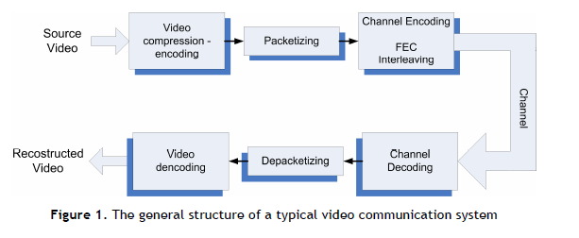
Figure 4.1: The general structure of a typical video communication system.

For effective video communications, reduction of raw video rates, i.e. video coding, is only the first of the necessary steps. The compressed bit stream is segmented into fixed or variable length packets. The packets could be sent directly over the channel, if the channel guarantied error-free transmission. However, this is not the case. Therefore, the packets usually undergo a Channel Coding stage, using Forward Error Correction (FEC) techniques and Interleaving, in order to become more robust against transmission errors. At the receiver, the received packets are Channel Decoded and unpacked, before the resulting bit stream is decompressed.
Transmission errors can be roughly categorized into,
a) Random bit errors and
b) Erasure errors, erasure errors are mainly caused in packet networks, such as the Internet. In video communication systems, such as the Digital Video Broadcasting - Space (DVB-S) system, we will concentrate mainly in random bit errors. The use of Variable Length Coding (VLC) (e.g. Huffman) makes compressed video vulnerable to random bit errors, because a bit error can desynchronize the coded information and many following bits are wrongly decoded or become undecodable.

Due to the above reason and the fact that video compression techniques use predictive coding (e.g. a frame is predicted from a previous one in MPEG), error control in video communications is a very challenging task. Because of VLC, a single error can cause damage over a large portion of a video frame. Furthermore, due to the use of temporal prediction, a single erroneously recovered sample can lead to errors in future frames, i.e. the error propagates temporally.

4.1.2 Channel Encoding
Forward Error Correction (FEC)
In order to render the bit stream more resilient to bit errors, the transmitter must add redundancy (i.e. some additional bits) to the stream, so that error detection and correction to become possible. This is done using Forward Error Correction (FEC) techniques. However, notice that the addition of bit redundancy is opposite to the idea of video compression/coding which aims to the reduction of the bit rate. Therefore, generally, FEC must be carefully designed. Due to the same reason, the problem of joint video and channel coding is studied by the scientific community in the last years.

The mathematician R. Hamming pioneered the idea of FEC in the 1940's and invented the first FEC code, the Hamming (7,4) code in 1950. FEC is accomplished using a predetermined algorithm to add redundancy into the transmitted information. A redundant bit may be a complex function of many original information bits. The original information may or may not appear literally in the encoded output.FEC codes that include the original bits input in the output are systematic, while those that do not are non-systematic.

In order to understand how it works, consider that a very simple example of a FEC code could be to transmit each data bit 3 (e.g.) times. This is a simple (3,1) repetition code. An error in any one of the three samples could be corrected by a "majority vote" or "democratic voting". The correcting ability of such a FEC code is up to 1 error bit in the triplet.
There are two main categories of FEC codes:
a. Block codes: This type of FEC codes works on fixed-length streams of bits. Practical block codes can generally be decoded in polynomial time to their stream length.
b. Convolutional codes: Convolutional codes work on bit streams of arbitrary length. They are most often decoded with the Viterbi algorithm. Viterbi decoding allows asymptotically optimal decoding efficiency with increasing constraint length of the convolutional code, but at the expense of exponentially increasing complexity.
Classical block codes and convolutional codes can be combined in concatenated coding schemes. In this case, a short constraint-length Viterbi-decoded convolutional code does most of the work. The block code (e.g. a Reed-Solomon code), with a larger block length, detects and corrects any errors made by the convolutional decoder.

Interleaving
Interleaving is a way to rearrange digital data in a non-contiguous way and it is frequently used in digital communication systems in order to improve the performance of Forward Error Correcting codes. In many cases of communication channels, errors typically occur in bursts rather than independently. Therefore, if the number of errors within a code word exceeds the error-correcting code's capability, the latter fails to recover the original code word. Interleaving helps us to override this problem by shuffling the source bits across several code words, thereby creating a more uniform distribution of errors.

Real Time Applications
Digital Video Broadcasting –Spacel, abbreviated as “DVB-S” is a European-based consortium standard for the broadcast transmission of digital television. DVB-S transmits compressed digital audio and video in an MPEG transport stream, using coded Orthogonal Frequency-Division Multiplexing (OFDM)modulation. With respect to Fig. 4.2, a coarse and short description of the DVB-S system follows. Notice that the diagram of Figure 4.2 is in agreement with general video transmission diagram of Figure 4.1.

Figure 4.2: A coarse description diagram of a DVB-T transmission system.

• Source coding and multiplexing: Source video and audio are compressed. Compressed video, audio, and data streams are multiplexed into MPEG program streams. One or more program streams are joined together into an MPEG transport stream, which is the basic digital stream transmitted and received by our TV sets.
• Packetizing: The MPEG transport stream is split into a sequence of 188-bytes-long packets. The byte sequence is decorrelated using an “energy dispersal” technique.
• External FEC encoder: A first level of FEC encoding is applied to the transmitted data. A non-binary block code, a Reed-Solomon RS (204, 188) code is used. This code allows the correction of up to a maximum of 8 wrong bytes for each 188-byte packet.
• Internal interleaver: An internal interleaver is used to rearrange the data sequence. A convolutional interleaver is used. The rearrangement is such that the transmitted data becomes more resilient to long sequences of errors.
• Internal FEC encoder: A second level of FEC error correction is applied. A punctuated convolutional code is used. There are five valid coding rates for DVB-T: 1/2, 2/3, 3/4, 5/6, and 7/8.
• Internal interleaver: An internal block interleaving technique is adopted to rearrange the data sequence again. This inner interleaver aims to reduce the influence of burst errors.
• Digital modulation mapper: QPSK, 16-QAM, or 64-QAM is used to map the bit sequence into a (baseband) sequence of complex symbols.
• Frame adaption: The complex symbols are grouped in blocks of constant length. A sequence of 1512,
3024, or 6048 symbols constitutes a block.
• OFDM modulation: The sequence of blocks is modulated using the OFDM technique, DVB-T uses 2048, 4096, or 8192 OFDM subcarriers (2k, 4k, 8k mode, respectively).

4.2 Video Error Concealment
Despite the use of channel coding techniques, uncorrected transmission errors often occur, which may lead to objectionable visual distortions in the reconstructed video at the decoder. When a video block is damaged or missing due to transmission errors, the decoder can estimate it based on surrounding received and correct blocks. This is a reasonable idea, based on the inherent spatial and temporal correlation among the video samples. Such techniques are known as “error concealment” techniques. Error concealment, in contrast to FEC coding, has the advantage of not employing any additional bits. However, error concealment increases the complexity of the decoder. There are two main types of information that may need to be estimated in a damaged MPEG Macro block (MB): a) The texture information, i.e. the pixel values (or the DCT coefficient values) for either an original block (I-frame mode) or a prediction error block (P- or B –frame mode), b) The motion information, consisting of Motion Vectors for a P- or B-mode Macro block. The recovery techniques for these information types are somewhat different.

It is well known that for natural (moving) images, the energy is concentrated in low frequency components, i.e. the intensity and colour values of spatially (and temporally) adjacent pixels vary smoothly, except in regions with edges. Therefore, the techniques that are used for texture information recovery make use of this smoothness property. They all perform some kind of spatial and/or temporal interpolation.

4.2.1 Spatial interpolation
The simplest approach to recover a damaged video block is to interpolate the damaged pixels from pixels in adjacent correctly received blocks of the same frame. However, the pixels in the centre of the block are far away from the pixels of the correct surrounding blocks. Therefore, spatial interpolation gives satisfactory results only for smooth regions of the image.

4.2.2 Motion compensated temporal prediction
Another simple but slightly more efficient approach to recover a damaged video block is to copy the corresponding block in a previously decoded frame. This approach is implemented in the IHU Virtual Lab Simulink model for video error concealment. However, it can produce satisfactory results only for static or slowly moving regions of the image. For regions of large motions a more effective solution is to use the block in the previous frame pointed to by the MV for the damaged block.

CHAPTER 5
SIMULINK IMPLEMENTATION
5.1 Simulink Basics
Simulink, developed by The Math Works, is a commercial tool for modelling, simulating and analyzing dynamic systems. Its primary interface is a graphical block diagramming tool and a customizable set of block libraries. It offers tight integration with the rest of the MATLAB environment and can either drive MATLAB or be scripted from it. Simulink is widely used in control theory and digital signal processing for simulation and design.
5.1.1 Introduction to Simulink
Simulink is an environment for simulation and model-based design for dynamic and embedded systems. It provides an interactive graphical environment and a customizable set of block libraries that let you design, simulate, implement, and test a variety of time-varying systems, including communications, controls, signal processing, video processing, and image processing.
Simulink offers:
- A quick way of develop your model in contrast to text based-programming language such as e.g., C.
- Simulink has integrated solvers. In text based-programming language such as e.g., C you need to write your own solver.
5.1.2 Start using Simulink
- Start Simulink from the MATLAB IDE:
- Open MATLAB and select the Simulink icon in the Toolbar:
Or type “simulink” in the Command window, like this:
Figure 5.1 Command Window.
Then the following window appears (Simulink Library Browser):
Figure 5.2 Simulink library browser.

The Simulink Library Browser is the library where you find all the blocks you may use in Simulink. Simulink software includes an extensive library of functions commonly used in modelling a system.
These include:
• Continuous and discrete dynamics blocks, such as Integration, Transfer functions, Transport Delay, etc.
• Math blocks, such as Sum, Product, Add, etc
• Sources, such as Ramp, Random Generator, Step, etc

5.1.3 Block Libraries
Here are some common used Continuous Blocks:

Here are some common used Math Operations Blocks:

Here are some common used Signal Routing Blocks:

Here are some common used Sinks Blocks:

In addition there are lots of block in different Toolboxes:
Figure 5.3 Simulink tool boxes.

5.1.4 Create a new Model
Click the New icon on the Toolbar in order to create a new Simulink model:
Figure 5.4: Simulink browser.

The following window appears:
Figure 5.5: Simulink new model window.
Now drag the blocks you want to use from the Simulink Library Browser to the model surface (or right-click on a block and select “Add to…”).

5.1.5 Wiring Techniques
Use the mouse to wire the inputs and outputs of the different blocks. Inputs are located on the left side of the blocks, while outputs are located on the right side of the blocks.
Figure 5.6: Simulink Input and Output blocks.
When holding the mouse over an input or an output the mouse changes to symbol.
Automatic Block Connection:
Another wiring technique is to select the source block, then hold down the Ctrl key while left-clicking on the destination block.

Connection from a wire to another block
If wire a connection from a wire to another block, like the example below, you need to hold down the Ctrl key while left-clicking on the wire and then to the input of the desired block.
Figure 5.7 Examples of connections.

5.1.6 Help window
In order to see detailed information about the different blocks, use the built-in Help system.

Figure 5.8: Simulink Help.

All standard blocks in Simulink have detailed Help. Click the Help button in the Block Parameter window for the specific block in order to get detailed help for that block.

The Help Window then appears with detailed information about the selected block:

Figure 5.9: Simulink Help Window.

5.1.7 Configuration
There are lots of parameters you may want to configure regarding your simulation. Select “Configuration Parameters…” in the Simulation menu.
Figure 5.10: Configuration parameters.

The following window appears:

Figure 5.11: Configuration dialog box.
Here we set important parameters such as:
• Start and Stop time for the simulation
• What kind of Solver to be used (ode45, ode23 etc.)
• Fixed-step/Variable-step
Solvers are numerical integration algorithms that compute the system dynamics over time using information contained in the model. Simulink provides solvers to support the simulation of a broad range of systems, including continuous-time (analog), discrete-time (digital), hybrid (mixed-signal), and multirate systems of any size.
Example: Sine Wave
Create the block diagram as shown below:

Figure 5.12: Simulink example of sine wave.

Set the following parameter for the Integrator block:

Figure 5.13: Example to set parameters

The result will be like this:

Figure 5.14: Simulink output window.

5.2 Building the Simulink Model
Simulink model for video compression using DCT is as follows.

Figure 5.15: Video compression Simulink Model to be implemented.

Input blocks:
1. Add a source file from Video and Image Processing Blockset → Sources → From Multimedia File. Set the filename to “vipmem.avi”, the sample time to “inf” and the output data type to “Single.”
2. Next convert the input color video from the file “vipmem.avi” to grayscale using Video and Image Processing Blockset → Conversions → Color Space Conversion. Set the conversion to “R’G’B’ to intensity.” Set the image signal to “One multi-dimensional signal.”

Processing blocks:
3. First we create the Compression & Encryption subsystem as shown in Figure 5.15. To create a place holder for this subsystem in the main Simulink file, we add a Block Processing block from Video and Image Processing Blockset→ Utilities. We need to extract an 8x8 block from the source image and perform different steps on it. This block extracts sub-matrices of a user-specified size from the input matrix. Then it sends each sub-matrix to a subsystem for processing, and then reassembles each subsystem output into the output matrix.
In the parameters for the Block Processing block, set the Number of inputs to 0 and1 and the Number of outputs to 1. Set the Block size to g{[8 8]} and Overlap to g{[0 0]}. Set the Traverse order to Row-wise. Now click on the Open Subsystem button and then create the Simulink model shown in Figure 5.15.
Figure 5.16: a) Compression block.
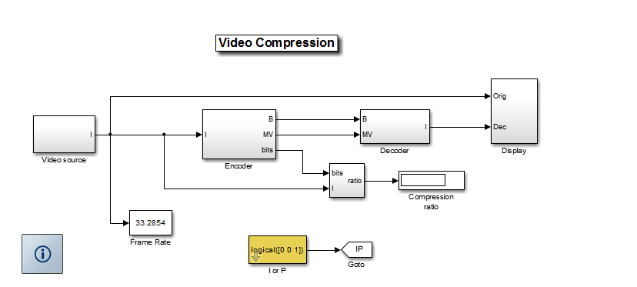
Figure 5.16: b) Video compression subsystem.

a) First we add the Embedded MATLAB function block where we write MATLAB code to descramble. The input variable ‘u’ in our case would be the block of 4x4 scrambled DCT coefficients. The output variable ‘y’ in our case would be the product of input variable with our descrambling matrix. The code for the function is given below in Figure 5.16.
b) Previously in Step 3, we used a Selector block to select a 4x4 block from an 8x8block of DCT co-efficients. Here we do the opposite i.e., we pad the 4x4 block of descrambled DCT co-efficients to get the 8x8 block of DCT co-efficients. Add the Image Padblock from Video and Image Processing Blockset → Utilities. Set the Method to “Constant” and Pad value source to “Specify via dialog.” Set the Pad value to “0” and Specify to “Padsize.” As we would be padding the 4x4 block to the right and bottom we set Pad rows at to “Right” and Pad columns at to “Bottom.” We set the Pad size along rows and Pad size along columns to “4”.
c) Add the 2-D IDCT block from Video and Image Processing Blockset → Transforms. Do not change any of the parameters in this block and leave them at their default values. Now we have computed the IDCT on a 8x8 block of pixels.

5. Finally, we create the Decompression subsystem. We need this subsystem to display the scrambled video. To create a place holder for this subsystem in the main Simulink file, we add a Block Processing block from Video and Image Processing Blockset → Utilities. In the parameters for the Block Processing block, set the Number of inputs to “1” and the Number of outputs to “1. “Set the Block size to “{[4 4]}” and Overlap to “{[0 0]}.” Set the Traverse order to “Row-wise”. Now click on the Open Subsystem button and then create the Simulink model. We repeat Steps 4 (b) and 4(c) to add the Image Pad and the 2-D IDCT blocks. Please note that Step 4(a) is not used here as we do not want to descramble the video here.

Figure 5.17: Decompression subsystem.

Output Blocks
6. Add three Video Viewer blocks from the Video and Image Processing Blockset> Sinks. Connect them to Decompression & Decryption subsystem, Decompression subsystem and to the input source. Figures 5.18(a), 5.18(b) show the original video, compressed video. We are compressing the video by ½ in this lab as we transmitted only a 4x4 block from an 8x8 block of DCT coefficients. Please note that in the compressed video the edges are blurry as the compression scheme we used is a lossy one. As we can notice in the scrambled video, our scrambling scheme is able to distort the original video making it not fit for normal viewing purposes.

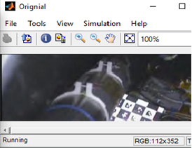
Figure 5.18 (a): Original video.

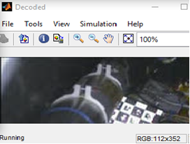
Figure 5.18 (b): Compressed video.

The video transmitter and receiver main blocks are presented in the Simulink video transmission system design. The incoming octet stream undergoes some initial processing in the “Frame Conditioning” block, like splitting and scrambling the MSBs and the LSBs into upper and lower branches octet streams. In the “Frame Encoding” block both streams are encoded with a Reed-Solomon code, interleaved and divided into four parallel streams that are convolutionally encoded and punctured. The multiplexer block interleaves and serializes all eight parallel bit streams. In the OFDM block the bit stream is converted to a complex coefficients stream by the system mapper and pilot, DC and null coefficients are inserted to form an OFDM symbol. The tone interleaver shuffles the order of the all sub carriers and the IFFT block converts the OFDM symbol to the time domain. The data received by the radio block is delivered to the receiver input, labelled “receiver in”, and processed by the “OFDM demodulation” block, where the time signal is converted to the frequency domain by the FFT block. The pilots, DC and null carriers are removed and the system demapper creates a bit stream from the receiver data coefficients. The demultiplexer block deinterleaves and separates the bit stream into eight parallel streams that are decoded by eight Viterbi decoders, deinterleaved and decoded again by 2 Reed-Solomon decoders. In the final block the two bit octet streams are de-scrambled and merged into a unique octet stream and provided to the upper layer.

5.3 Transceiver blocks
5.3.1 Transmitter and receiver controller
The configuration of all the transmitter blocks and sub blocks is performed by the transmitter controller block. It decodes the information on the HRPDU header and configures the system accordingly. The receiver controller block is responsible for configuring all the blocks on the receiver model. It decodes the transmitted HRPDU header and generates all the signals to configure appropriately all the remaining blocks.

5.3.2 Frame processing blocks
The frame conditioning block, represented in Figure 5.19, is formed by three sub blocks: the stuff bits block, the splitter block and the scrambler block. The bit stuffer is responsible for ensuring that the transmitter produces an integer number of OFDM symbols; the splitter only processes payload data; separates and reorders each incoming octet in the 4 MSBs and 4 LSBs; the scrambler scrambles all data bits using a polynomial scrambler.

Figure 5.19: Frame conditioning block (transmitter).
The reciprocal block in the receiver is the also called frame conditioning block, illustrated in Figure 5.20, and its main blocks are the destuff bits block; the desplitter block and the descrambler block.

Figure 5.20: Frame conditioning block (receiver).

5.3.2.1 Splitter and desplitter
The splitter block is used to reorder and divide HRPDU sub frames into two different bit streams, designated as lower and upper bit streams. The HRP header and sub-frames transmitted with modes 5 and 6 are not processed by the splitter and desplitter blocks. Sub-frames using HRP modes 0 to 2 are divided into lower and upper bit streams; sub-frames using HRP modes 3 to 4 are split.

5.3.2.2 Scrambling and descrambling
Input stream bits, including the HRP header, are scrambled by a polynomial scrambler defined by,
P(x) = $x^{15}+x^{14}+1$ (5.1)
The initial values in the delay line are given by eleven fixed seeds and four variable seeds, S0, S1, S2 and S3: [x-1,x-2,..,x-15]=[1101 0000 101S3 S2S1S0]. The HRP header is scrambled with S0S1S2S3= [0101]. The payload bits, including the stuff bits, are scrambled using the seeds specified in the PHY Control field22. The first eight bits of the scrambler are applied to the lower branch and the next eight bits to the upper branch, alternating every eight bits between the two branches. Figure 5.21 illustrates the inner structure of the scrambler and descrambler blocks.
Figure 5.21: HRP scrambler and descrambler block.

The scrambling process for the HRP header is different from the scrambling done to the data because it is not split into upper and lower branches. For this reason it was decided to process the header and the data payload using two different blocks, the header scrambler and the scrambler. Each of these blocks implements a delay line with constraint length K=16 sixteen and 15 delay memory elements. The output of the scrambler is the result of the 1-bit sums without carry of each data bit and the values in the sixteenth, fifteenth and first positions in the delay line.

5.3.3 Frame encoding and decoding blocks
The frame encoding block has three main sub blocks: incoming octets are encoded by the Reed-Solomon encoding block, and then the outer interleaver block groups, reorders and distributes the data by the eight convolutional encoders that make up the convolutional encoder block.
On the receiver side, the data undergoes the reverse processing: first the eight Viterbi decoders recover the data, which is then deinterleaved and regrouped by the outer deinterleaver and then decoded by the Reed-Solomon decoding block.

5.3.3.1 Reed-Solomon encoder and decoder
Three different codeword lengths are used for encoding the HRPDU frame: the first 48 octets of the header are encoded with a RS (56,48) code, the remaining 44 HRP header octets are encoded with a RS (52,44) code and the payload octets are encoded using a RS(224,216) code.
Figure 5.22 and Figure 5.23 show the internal structure of the Reed-Solomon encoding and decoding blocks. The main blocks of the Reed-Solomon encoding block are two Reed-Solomon encoders working in parallel encoding simultaneously the upper branch data and the lower branch data. The implemented RS encoder blocks can perform all three encoding schemes. The additional blocks are used for splitting, routing the header data to both RS encoders and appending four null symbols to the portion of the header that is encoded using the RS(52,44) code.

Figure 5.22: HRP transmitter Reed-Solomon encoder.

Figure 5.23: HRP receiver Reed-Solomon decoder block.

The RS decoding block performs the data decoding and error correction using two parallel RS decoders. These blocks use the native matlab Reed-Solomon decoder function: rsdec.m. Additional data routing blocks were necessary to use both RS decoders to decode the model header.

5.3.3.2 Outer interleaver and outer deinterleaver
The outerinterleaver block uses two interleavers, one for the upper branch data and another for the lower branch data. Each interleaver distributes data to four convolutional encoders. The internal structure of the outerinterleaver block in represented in Figure 5.24.

Figure 5.24: Outer interleaver block internal structure (transmitter).

For all HRP modes the depth is defined to be four; the depth used in the HRP header is two. The matlab functions funct outer interleaver. m groups depth × N sets of octets and implements for depths 2 and 4. In the receiver the reverse operation is implemented by the outer deinterleaver blocks.
5.3.3.3 Convolutional encoder and decoder
After being interleaved the data is encoded by a convolutional code. The encoder block is composed by eight convolutional encoders in parallel, four for the data of each interleaver block. The structure of each individual encoder is presented in Figure 5.25. The decoding operation on the receiver is done by eight Viterbi decoders in parallel. The Matlab function that implements the convolutional decoder, sfunct_viterbi_decoder.m, uses the Matlab built in function, vitdec.m, to perform the decodification and data puncturing. This block is prepared to handle soft decoding in which the logic values “0” and “1” are represented by a value between 0 and 2nbits-1, where n bits is the number of bits in each soft bit.

Figure 5.25: Individual convolutional encoder structure.

5.3.3.4 Puncturing
The convolutional encoder native code rate is 1/3; the other coded rates defined are generated by the puncturing block which selects which bits will be transmitted from each of the three streams. The data bits are selected and serialized according to the puncturing pattern and transmission sequence. On the receiver side the puncturing is done by the Viterbi decoders.

5.3.4 Bit interleaver and deinterleaver blocks
The bit streams generated simultaneously by the convolutional encoders are serialized and interleaved in the multiplexer/bit interleaver block. The structure of the multiplexer and bit interleaver block is presented in Figure 5.26. The main blocks are the header multiplexer/bit interleaver and data multiplexer/bit interleaver, the additional blocks just perform data routing.

Figure 5.26: Multiplexer/bit interleaver block internal structure.

The HRP header is processed by a separate block because it utilizes a different grouping and interleaving scheme: 12 sequential bits from each stream are grouped and interleaved to form a single stream with 48 bits.

The data multiplexer/bit interleaver has two different working modes: the EEP and UEP modes. In the EEP mode all eight puncturing blocks use the same code rate and the incoming bits are multiplexed and interleaved every 48 bits. The EEP multiplexer groups six bits, in increasing order of time, from each encoder, from A to H, and serializing them by ordering bits A1 to A6, B1 to B6, C1 to C6, D1 to D6, E1 to E6, F1 to F6, G1 to G6, H1 to H6 and interleaving them.

The bits are then interleaved. In the second phase, the UEP multiplexer, groups again seven bits from each of the upper puncturing blocks, and five bits from each of the lower puncturing blocks and serializes the bits from B8 to B14, C8 to C14, D8 to D14, A8 to A14, F6 to F10, G8 to G10, H8 to H10, and finally E7 to E10'. The HRP demultiplexer/bit deinterleaver block is represented on Figure 5.27.

Similarly to the multiplexer/bit interleaver block the main blocks are the header demultiplexer and data demultiplexer. These blocks deinterleave the data stream received from the system demapper and separate it into parallel bit streams.

Figure 5.27: HRP demultiplexer and bit deinterleaver.

5.3.5 OFDM modulator and demodulator blocks
The OFDM modulator, Figure 5.28, includes the following blocks: system mapper, preamble, pilots insert blocks, tone interleaver, the IFFT block and some additional routing blocks.

The serial data stream is mapped to complex coefficients by the system mapper and the insert pilots block adds the null, dc and pilots. The carriers are interleaved by the tone interleaver block and the IFFT block converts the OFDM symbol to the time domain and the signal is sent to the radio block. Each OFDM symbol has 512 sub carriers: 336 modulated by data, 157 null carriers, 16 pilot carriers and 3 DC carriers.

Figure 5.28: OFDM modulator block.
The OFDM demodulator block, Figure 5.29, performs the reverse processing: the received signal is converted to the frequency domain by the FFT block, the complex coefficients are deinterleaved and the pilots, null and DC coefficients are separated from the data coefficients and the system demapper block converts the complex coefficients into a bit stream.
Figure 5.29: OFDM demodulator block.

5.3.5.1 Mapper and Demapper
The system mapper maps groups of bits from the HRP multiplexer/bit interleaver to complex coefficients that will be used to modulated the OFDM data sub carriers.
The system demapper performs soft decoding. Soft decoding represents logical levels with several bits, nbits, to indicate the uncertainty associated with the demapping of each bit. The demapper output for each bit varies from 0, certain “0” bit, to 2nbits-1, certain “1”.

5.3.5.2 IFFT and FFT blocks
The IFFT block transforms the 512 complex coefficients, corresponding to a representation in the frequency domain, into 512 complex coefficients in the time domain. The FFT block recovers the coefficients in the frequency domain. The IFFT and FFT blocks are built around the native Matlab functions ifft.m and fft.m.

5.4 Complete Matlab/Simulink model
The top level overview of the Matlab/Simulink model is presented in Figure 5.30. To simulate the transceiver operation two additional blocks were introduced: the HRDPU frame generator block and a channel block.
Figure 5.30: Complete Simulation model.

The HRPDU frame generator block creates the data that will be transmitted and the channel block simulates several transmission channel models.

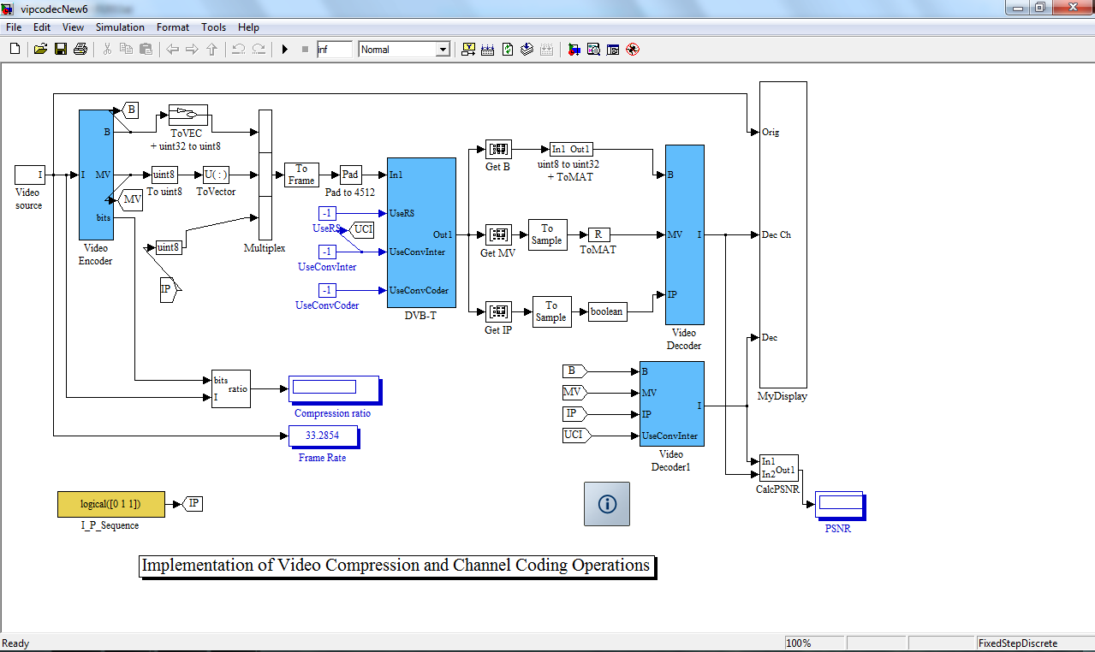
Figure 5.31: Video transmitter and receiver blocks.
Figure 5.31 is the implemented video transmission simulink model. The simulink model gives detailed information about compression ratio, SNR, bit error rate, PSNR. The compression and channel coding blocks are designed to form a single system. Both the compression and channel coding system are connected. First compression takes place then the compressed video data is sent into the channel and by applying channel coding techniques, error free transmission is achieved.

CHAPTER 6
RESULTS AND DISCUSSION

We have implemented the video transmission system using MATLAB. Using Simulink and Graphical user interface, we have designed the required compression and channel coding system for error resilient video transmission. Based on the GUI design we have discussed the result as follows:

Digital Video Broadcast – Terrestrial (DVB-T) “DVB-T” User Guide
The Graphical User Interface (GUI), is used for the simulation of MPEG video compression and transmission over noisy channels. Specifically, the simulation is performed with the use of a Matlab-Simulink model, which compresses the input video according to the MPEG standard and models a part of the ETSI (European Telecommunications Standards Institute) EN 300 744 standard for terrestrial transmission of digital television signals (Digital Video Broadcast Terrestrial, DVB-T). The main part of the model and the DVB-T channel encoding-transmission-decoding subsystem are given in Figure 4.2.

The GUI helps the user to change the model’s parameters, during the simulation. With the use of this demo the user can study:
• The effects of transmission errors to the quality of the decoded video.
• The idea of Forward Error Correction (FEC) / Channel Coding techniques.
The user can select any input video. Using the selected video, the model simulates:
• The MPEG compression, with all of its components:
o Block DCT transform,
o Block Matching Motion Estimation,
o Quantization and entropy coding.
• The Channel coding operations, applied by a DVB-T transmitter:
o Reed Solomon coding,
o Convolutional encoding,
o Interleaving, etc.
o Modulation according to DVB-T: 64-QAM and 2-K OFDM.
• Transmission over Additive White Gaussian Noise (AWGN) channel
• Demodulation.
• Channel Decoding.
• MPEG decoding.
The user can view the input video, the compressed one and the video at the receiver. Furthermore, the user can study the (baseband) OFDM spectrum of the received signal.
Figure 6.1: A snapshot of the “DVB-T” GUI. The used notation is explained in the text.

Figure 6.2: An example of the GUI’s usage and some conclusions.

Figure 6.2 gives the information about the video transmission in the absence of channel coding schemes. The maximum SNR given in this design is 25 dB, so when it comes below that given value, errors will be more. So if the channel coding is not used, we will get the results as,
• Channel coding is not used.
• SNR = 21 dB
• BER = 0.3 %
• Many video blocks are destroyed, although only a few bits are wrongly decoded.
• Low quality for the decoded video.
• Very low PSNR
Hence for error free video transmission channel coding is essential.

In figure 6.3, we have used channel coding. We analyze the transmission using convolution coding and we can use both the coding schemes at a time to ensure the error free transmission in the Additive White Gaussian Noise Channel. When SNR value is 17dB, if we use only the Convolutional encoder, we will get the following results:
• SNR = 17 dB
• BER = 0.15 % (lower than in Figure 6.2)
• Better quality at the decoder.
• Higher PSNR.

Figure 6.3: A second example of the GUI’s usage and some conclusions.

Error control schemes are necessary to obtain good video quality in the presence of high bit error rate. Traditionally, FEC codes have been used for real-time services because they maintain a constant throughput and a bounded delay. FEC codes can be chosen to guarantee certain error rate requirements for the worst channel conditions. The goal of this thesis is to decrease the number of erroneous bits using error correcting codes (ECC). Two FEC scheme has been discussed in this thesis. In the first forward error correction scheme, the data is not prioritized and various segments in the video stream are given equal importance. The FEC coder supplements each segment with the same number of parity bits. RS Coding is used for this case.

The second scheme is the outcome of the sensitivity analysis experiments. In this scheme, a stronger FEC is applied to the first frame (the first I frame) as the important data is found in it. Hence Convolutional coding shown in figure 6.3 is used for the rest inter frames. The main aim of the algorithm is to strengthen the video stream against most possible error cases and also reduce the percentage of the overhead bits arising because of FEC coding. The strength of the FEC can be varied based on system average BER.

The EBMA for H.264 was written in Matlab. Half pixel precision is used for motion compensation. The module has two segments. One for encoding the raw QCIF video stream and the other to decode the H.264 stream provided. After H.264 encoding, the resultant bit stream was FEC encoded which will be digitally modulated using 64 QAM and OFDM Transmitted. Additive white Gaussian noise was added to the resultant spreaded bit stream. AWGN noise was added for a particular SNR after measuring the strength of the resultant stream. Each point on the graph corresponds to only one error count value. The decoder after receiving the bit stream first performs OFDM demodulation using the matched filter concept and then passes it through the FEC program to correct the errors present based on the particular FEC strategy used. After error correction it decodes the data to generate the raw video again. Finally, the PSNR values are calculated by comparing the input raw video with the output. The value is plotted against the noise factor that was artificially fed in. The value is plotted against the BER, since only the relative performance is of significance.
Figure 6.4: Variation of bit error rate (BER) with SNR for different values.

The simulation was also carried out by varying the signal-to-noise ratio of AWGN Channel using different FEC techniques like combination of RS and Convolutional was adopted to see the effect of signal-to-noise ratio on bit error rate. It was observed that if the number of redundant bits is increased or the convolutional code can correct more errors, then the bit error rate is achieved at lower signal-to-noise ratio.

By adjusting the SNR values we compare the BER for both with channel coding and without channel coding transmission. It is observed from the Table 6.1, that convolutional encoder is more capable of reducing the BER.

Table 6.1. SNR vs BER Values For Different Techniques.
 | Bit Error Rate ( BER )
SNR  (dB) | Without  channel  coding | Reed-  Solomon  Encoder | Convolutional  interleaving | Convolutional  Encoder
15 | 5.354 | 5.220 | 5.0523 | 4.95
16 | 4.21 | 4.122 | 4.005 | 0.965
17 | 3.120 | 3.053 | 3.9 | 0.1856
18 | 1.85 | 1.789 | 2.02 | 0.0095
19 | 1.225 | 1.234 | 1.21 | 0.0001
20 | 0.785 | 0.650 | 0.632 | 0
21 | 0.432 | 0.0445 | 0.407 | 0
22 | 0.215 | 0.0043 | 0.1632 | 0
23 | 0.045 | 0.00 | 0.0056 | 0

Similarly the PSNR values are tabulated for different SNR values . It is noted that, as the SNR value increases PSNR gradually increases.
Table 6.2. SNR vs PSNR Values For Different Techniques.
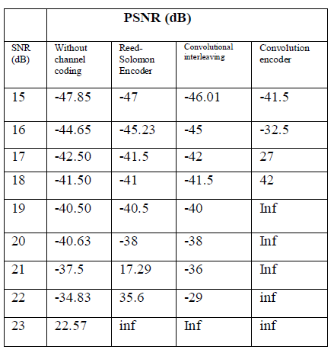

The graph of SNR vs PSNR is plotted for all the coding techniques
Figure 6.5: Plot of SNR vs PSNR.
The project concludes that the transmitted errors recovery with Convolution Encoder gives better results as compared to other technique and by seeing at the results we can say that convolutional encoder provide better quality of video at 5dB lesser than all other techniques.
CHAPTER 7
CONCLUSION
7.1 Conclusion
In this thesis, we proposed an error resilient video transmission system. Using the MATLAB-Simulink we designed the video transmission system by combining the compression and channel coding methods. Owing to the applied compression, H.264 is very vulnerable to bit errors due to noise present in the channel. Hence error correction effort is needed to control error in the video stream. FEC scheme has been implemented to control error in the video stream as compressed video stream is fragile in the presence of error. FEC of different strength is also used to observe the effect of SNR on BER. The strength of the FEC code provides another degree of freedom in improving quality. Convolution and RS coding methods, helped in reducing the BER. Compression and channel coding methods form an efficient video communication system.

From the simulation results we can conclude that, convolution coder is efficient in controlling the errors when compared to RS coding. In this project we have used both the coding methods at a time. Hence it is an added advantage to reduce the bit error rate. The use of interleaver has increased the efficiency of the coding methods.

7.2 Future Work
In this work we have considered only luminance, so it can be extended by considering the chrominance. It can be implemented in real time applications like deep space communication, Satellite communication and error free video transmission in streaming applications. Viterbi coding can also be included in the design for long distance video transmission.

REFERENCES
[1] Rijkse, Karel, “H.264: Video Coding for Low-Bit-Rate Communication”, IEEE Communication Magazine. Vol. 34, (December 1996): pp.42-45.
[2] Dufaux,F. and Moscheni, F., “Motion Estimation Techniques for Digital TV: A Review and a New Contribution”. Proc.IEEE.Vol.83, no.6, (June 1995): pp.858-876.
[3] Aroh Barjatya, “Block Matching Algorithms for Motion Estimation”. IEEE. Student Member, (April 2004).
[4] Jain, Jaswant, and Jain, Anil, “Displacement Measurement and Its Application in Interframe Image Coding”. IEEE Transactions on Communications.Vol.COM-29, No.12 (December 1981).
[5] Wu, Siu-Wai and Gersho, Allen, “Joint Estimation of Forward and Backward Motion Vectors for Interpolative Prediction of Video”. IEEE Transactions On Image Processing.Vol.3, No.5 (September 1994).
[6] Chen,Lei and Lee, Chung-wei, ”Multi-level secure video streaming Over SRTP”.43rd ACM Southeast Conference.(March18-20,2005).
[7] Rhee, I., “Error Control Techniques for Interactive Low-Bit rate video transmission”. ACMSIGCOMM ’98, (1998).
[8] Toshun, A., and Feng, W., “On improving quality of video for H.264 over wireless CDMA networks”. IEEE Wireless Communications and Networking Conference, (2000).
[9] Chunbo Zhu, Ye-Kui Wang, M.M. Hannuksela, Houqiang Li , “Error Resilient Video Coding Using Redundant Pictures”. IEEE Transactions on Circuits and Systems for Video Technologyy
[10] Zhao, C., Nqan, K.N., “Error Sensitivity Analysis for Macro block Bitstream”. Proceedings of IEEE TENCON, (2002).
[11] Wang, Y., Ostermann, J., and Zhang Ya-Qin. Video Processing and Communications. Upper Saddle River, New Jersey: Prentice Hall, 2002.
[12] Ohm, J.R. Multimedia Communication Technology. New York: Springer International Edition, 2004.
[13] Bose, Ranjan. Information Theory Coding and Cryptography. New Delhi: Tata McGraw-Hill Publishing Company Limited, 2002.
[14] Elsevier J. of Visual Communication & Image Representation (Special issue on Emerging H.264/AVC Video Coding Standard), Vol. 17(2), April 2006.
APPENDIX

Appendix –A: MATLAB Implementation

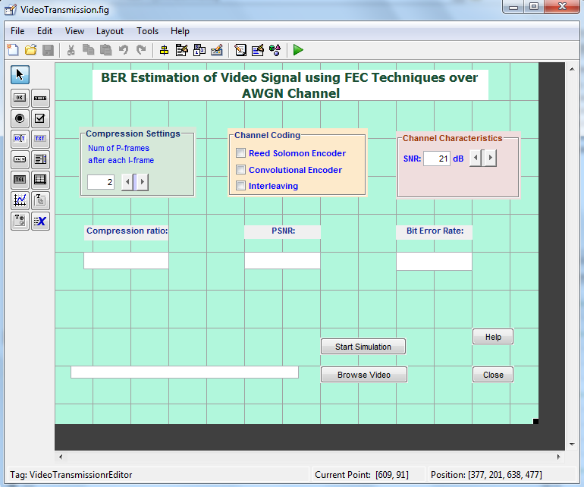

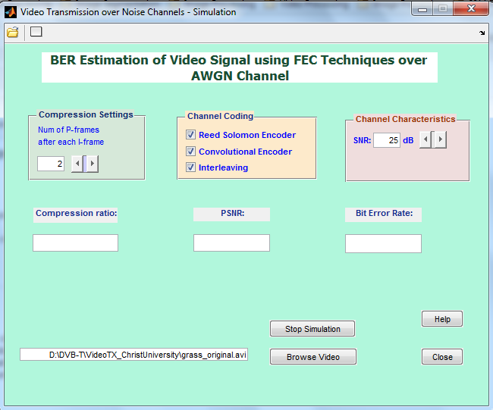

Snapshot of designed GUI.
Appendix –B: Simulink Models

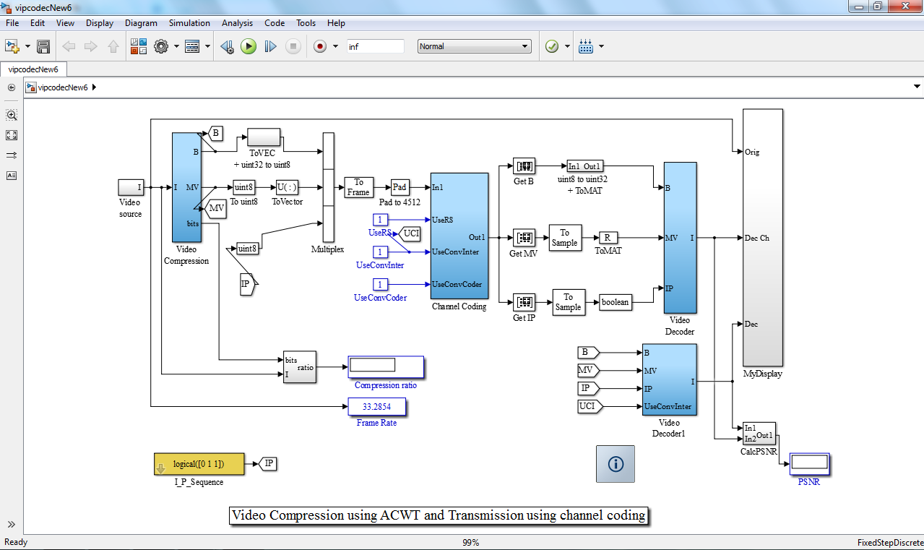

Video transmission system.

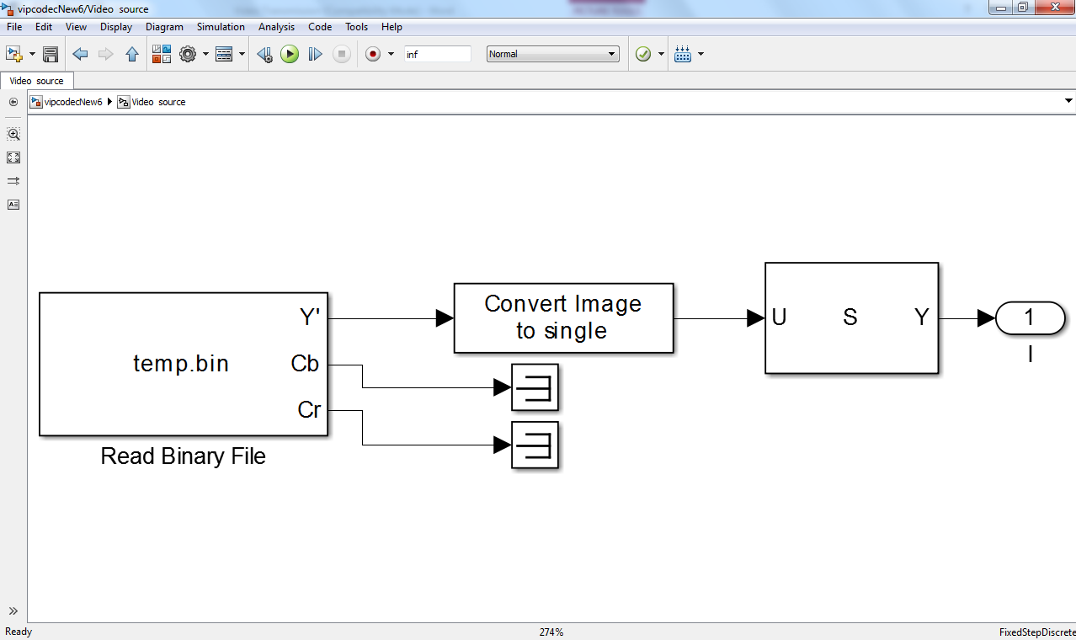
Compression blocks

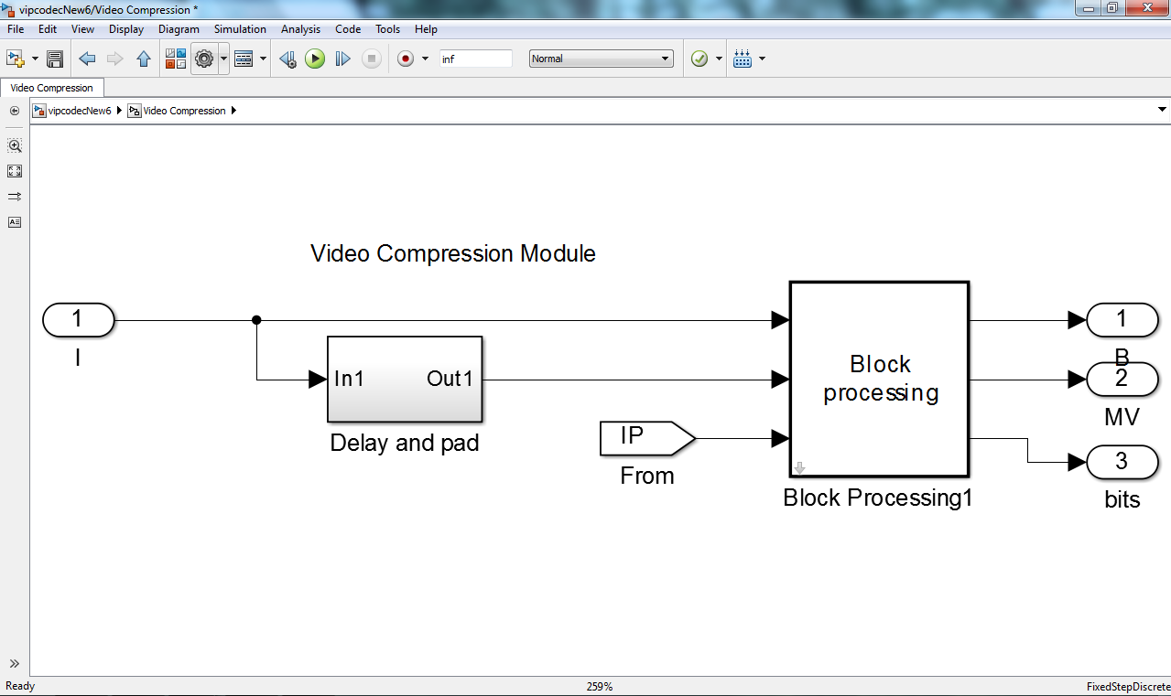

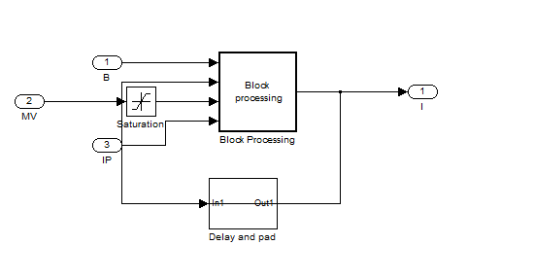
Compression modules.

